2011 Water Quality Report for The
Cass Lakeside Community Association
Water Department 248-732-7317

This report covers the drinking water quality for Cass Lakeside Community Association for the calendar year 2011. This information is a snapshot of the quality of the water that we provided to you and the details about where your water comes from, what it contains, and how it compares to Environmental Protection Agency (EPA) and state standards.

Your water comes from two groundwater wells located within the subdivision. The water from each well is alternately pumped to the above the ground storage tank. The State performed an assessment of our source water in August 2011. Our water supply assessment was rated LOW and includes geological sensitivity, water chemistry, and contaminant sources.
- Contaminants and their presence in water: Drinking Water, including bottled water, may reasonably be expected to contain at least small amounts of some contaminants. The presence of contaminants does not necessarily indicate that water poses a health risk. More information about contaminants and potential health effects can be obtained by calling the EPA'S Safe Drinking Water Hotline (800-426- 4791).
- Vulnerability of sub-populations: Some people may be more vulnerable to contaminants in drinking water than the general population. Immune-compromised persons such as persons with cancer undergoing chemotherapy, persons who have undergone organ transplants, people with HIV/AIDS or other immune systems disorders, some elderly, and infants can be particularly at risk from inferiors. These people should seek advice about drinking water from their health care providers. EPA/CDC guidelines on appropriate means to lessen the risk of inferior by Cryptosporidium and other microbial contaminants are available from the Safe Drinking Water Hotline (800-426-4791).
- Sources of drinking water: The sources of drinking water (both tap water and bottled water) include rivers, lakes, streams, ponds, reservoirs, springs, and wells. Our water comes from wells. As water travels over the surface of the land or through the ground, it dissolves naturally-occurring minerals and, in some cases, radioactive material, and can pick up substances resulting from the presence of animals or from human activity.
- Contaminants that may be present in source water include:
  - Microbial contaminants such as viruses and bacteria, which may come from sewage treatment plants, septic systems, agricultural livestock operations and wildlife.
- Inorganic contaminants, such as salts and metals, which can be naturally-occurring or result from urban stormwater runoff, industrial or domestic wastewater discharges, oil and gas profusion, mining or farming.
- Pesticides and herbicides, which may come from a variety of sources such as agriculture and residential uses.
- Radioactive contaminants, which are naturally occurring or be the result of oil and gas production and mining activities.
- Organic chemical contaminants, including synthetic and volatile organic chemicals, which are by-products of industrial processes and petroleum profusion, and can also come from gas stations, urban stormwater runoff, and septic systems.

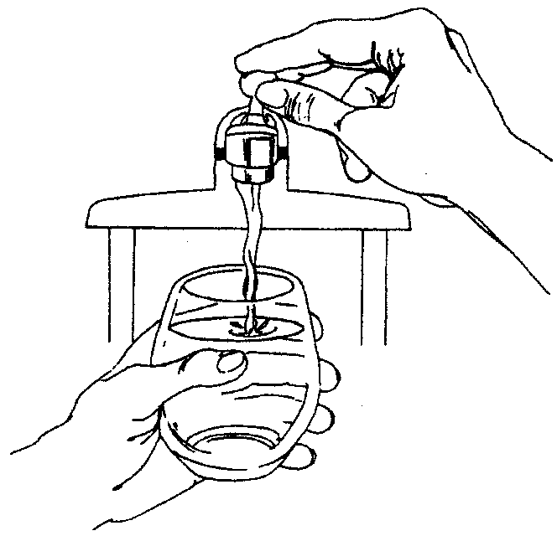
In order to ensure that tap water is safe to drink, EPA prescribes regulations that limit the amount of certain contaminants in water provided by public water systems. Food and Drug Administration regulations establish limits for contaminants in bottled water which provide the same protection for public health.

The table below lists key drinking water contaminants that we tested for during the 2011 calendar year. The presence of these contaminants in the water does not necessarily indicate that the water poses a health risk.
Unless otherwise noted, the data presented in this table is from testing done January 1 - December 31, 2011 The State allows us to monitor for certain contaminants less than once per year because the concentrations of these contaminants are not expected to vary significantly from year to year. All of the data is representative of the water quality but some are more than one year old.

Terms and abbreviations used below:
- Maximum contaminant Level Goal (MCLG): The level of a contaminant in drinking water below which there is no known or expected risk to health. MCLGs allow for a margin of safety.
- Maximum Contaminant Level (MCL): The highest level of a contaminant that is allowed in drinking water. MCLs are set as close to the MCLGs as feasible using the best available treatment technology.
- N/A: Not applicable ND: not detectable at testing limit ppb: parts per billion or micrograms per liter ppm: parts per million or milligrams per liter pCi/l: picocuries per liter (a measure of radioactivity).
- Action Level: The concentration of a contaminant which, if exceeded, triggers treatment or other requirements the water system must follow.
Regulated Contaminant | MCL | MCLG | Level Detected | Sample Date | Violation Yes / No | Typical Source of Contaminant
Floride (mg/l) | 4 | .1 | .7 | 9/27/2011 | No | erosion of natural deposits; discharge from fertilizer and aluminum factories
Nitrate (mg/l) | 10 | .4 | none | 9/27/2011 | No | Runoff from fertilizer use; Leaching from septic tanks, sewage; Erosion of natural deposits
Nitrite (mg/l) | 1 | .05 | none | 9/27/2011 | No | Runoff from fertilizer use; Leaching from septic tanks, sewage; Erosion of natural deposits
Sodium (mg/l) | n/a | n/a | 15 | 9/27/2011 | No | Erosion of natural deposits
Contaminant subject to AL (2009) |  |  | Action Level | 90% of Samples < This Level | Number of Samples Above AL | Typical Source of Contaminant
Lead (ppb) |  |  | 15 | 0 | 1 out of 10 | Corrosion of household plumbing systems; erosion of natural deposits
Copper (ppb) |  |  | 1.3 | 0 | 0 out of 10 | Corrosion of household plumbing systems; erosion of natural deposits; Leaching from wood preservatives
Microbial Contaminants | Violation Yes / No |  | Results | Sample Date | Typical Source of Contaminant
Total Coliform Bacteria | No |  | Negative | Monthly | Naturally present in the environment
Fecal Coliform and E. coli | No |  | Negative | Monthly | Human and animal fecal waste
The State and the EPA require us to test our water on a regular basis to ensure its safety. We met all the monitoring and reporting requirements for 2011. There were no anomalies. We will update this report annually and will keep you informed of any problems that may occur throughout the year, as they happen. We invite public participation in decisions that affect drinking water quality. CLCA Board Meetings are held the 2nd Tuesday of every month at 7:30 pm. For more information about safe drinking water visit the EPA website at www.epa.gov/safewater/ Contact CLCA Water Chairman Steve O'Connor or Dan Krause

For more information, please contact Mr. Steve O'Connor or Dan Krause at 248-732-7317 or the DNRE at 586-753-3755.

Please share this information with all the other people who drink this water especially those who may not have received this notice directly (for example, people in apartments, nursing homes, schools, and businesses). You can do this by posting this notice in a public place or distributing copies by hand or mall.
This notice is being sent to you by Cass Lakeside Subdivision.

CERTIFICATION: WSSN: 01230 l certify that this water supply has fully complied with the public notification regulations in the Michigan Safe Drinking Water Act, 1976 PA 399, as amended, and the administrative rules.

Signature: _____________________ Title __Chairman______________________Date Distributed__6/28/2012______

